Semaphore Short Friday 17 April 2026

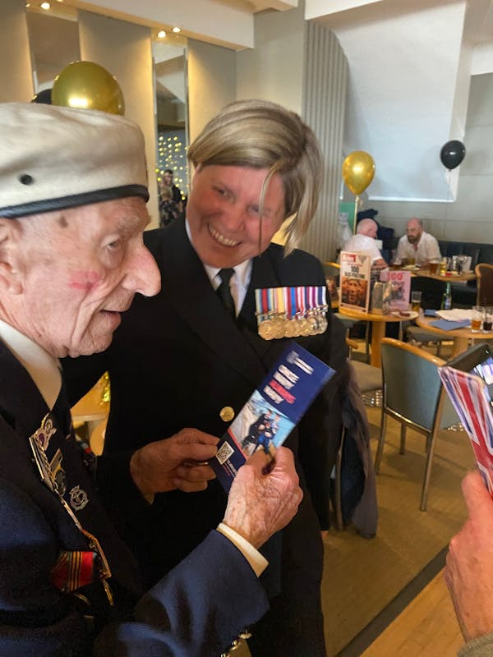

Birthday wishes for centenarian Alec

No one would want to be in hospital on their birthday – especially when you’re already into three figures. World War 2 veteran S/M Alec Penstone celebrates his 101st birthday on Thursday 23 April, but is currently poorly and being looked after at St Mary’s Hospital on the Isle of Wight.

He will not be able to return home for the big day, but if you would like to help lift his spirits you could send him a card. If you do, send it to this address:

FAO Shipmate Alec Penstone
c/o 20 West Hill Road
Ryde
Isle of Wight
PO33 1LG

and his shipmates will make sure he gets them. Alec was in his mid-teens when war broke out, and after serving as a part-time Air Raid Precautions messenger – including through the Blitz in London – he joined the Royal Navy and served in escort carrier HMS Campania, which was involved in escorting Atlantic and Arctic convoys. The RNA is honoured that Alec is one of our beloved members, and as an organisation we wish him comfort and care.

RNA General Secretary Capt Bill Oliphant said: "We are so sad to hear of Alec's illness. I had the great pleasure of celebrating his 100th birthday with him last year and noted his charisma and charm. In fact, the D Day Darlings attended his party too and Alec insisted on dancing with them to the exclusion of everyone else. He is a legend and we honour him deeply."

  It will only take you a few minutes to complete the RNA 2026 membership survey, which will enable us to understand all members’ views on the Association and its activities.
  And for one lucky entrant, drawn at random, there will be a £100 Amazon gift voucher for their trouble.
  Completing the survey will help us to deliver more of what members want and need – and if you could all add your email addresses, this would enable us to communicate more effectively with members.
  To take part in the survey please use this link:
  https://forms.office.com/e/wbauj6qJmm
  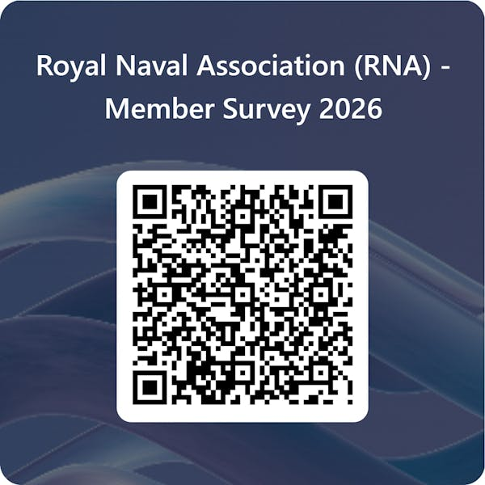

Raffle – watch this space

Staff at RNA Central Office are putting together a raffle to coincide with the Army v Navy rugby clash at Twickenham on Saturday 2 May – keep an eye on our social media channels for more information.

  Tee time on National Conference weekend
  RNA golfers will be competing for honours at the Association’s National Golf Competition on Friday 12 June at the start of National Conference weekend in the North-West.
  The venue is Ellesmere Golf Club (https://www.ellesmeregolfclub.co.uk/), with the first tee at 1030.
  This year sees the first Ladies Team competing for the Salver at Ellesmere GC. The event will be full handicap; Stableford and ALL scores will count towards the overall team winners.
  

  Individual prizes will also be up for grabs, including the standard NTP and longest drive competitions.
  Registration for this event will close on Tuesday 30 April, so if you haven’t registered yet, contact S/M Mac McAllister (kevinmac31@tiscali.co.uk) with your full name and HC (using WHS).
  You can enter as a singleton player or a four-ball team – team names to be submitted at registration.
  Cost is £44 per player, which includes the round and tea/coffee/bacon rolls prior to tee off. Tea/ coffee post-round with presentations and awards to follow. There is a bar at the club, which will be open.
  Payment details are:
  Name: K McAllister
  Sort Code: 30-96-68
  Acc No: 06120633
  Ref: Surname/ RNA Golf

  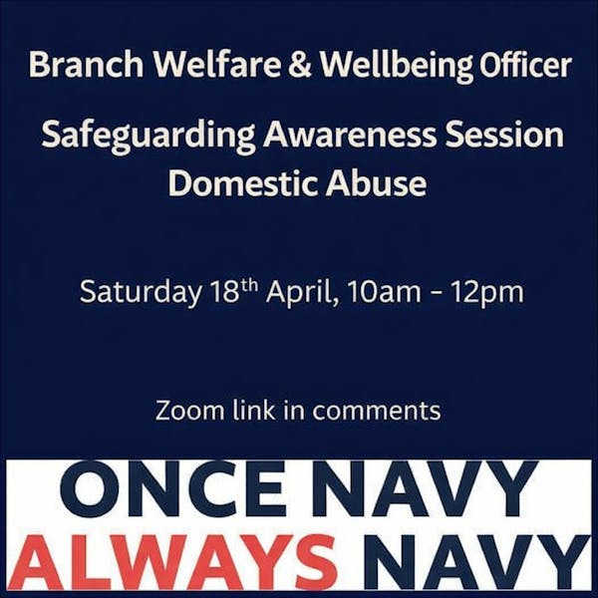
  The Zoom link is HERE
  Please contact RNA Welfare and Wellbeing Co-ordinator Jon Everett for further information if you would like to volunteer to become a Welfare and Wellbeing Officer – wws@rnassoc.org

Naval charities launch tutoring scheme

Greenwich Hospital and the Naval Children’s Charity have launched a national online tutoring pilot to support serving Royal Navy and RFA families.
This major new pilot initiative, dubbed Go Learn, will provide high-quality, non-means-tested, one-to-one online tutoring to secondary school aged students at key educational stages – GCSEs, A Levels, Scottish Nationals and Highers, also to students with additional needs.
For more details see the May edition of the Semaphore Circular, out on Friday 2 May.

 |  |  |  |  |  |  |  |  |  |  | 

